**Table of Contents**

**Mock Spring Script 2**

Duration: 2 hours

Part 1: Setup 2

Part 2: Script 2

Recommendations: Treasury Board

**Part 1: Setup**

* Create a personal VSTS team account with an Outlook email address (or other non-Microsoft email). Create a Google Doc file and give out the URL to the class
* Ask for class to add their personal accounts onto the Google Doc file sometime throughout the day before the lab will be conducted.
  + PO = Stakeholder
  + Project Manager or Scrum Master = Basic - Admin (2)
  + BAs = Basic – Contributor (1)
  + Dev = Basic – Contributor (1)
  + QA = Basic – Contributor (1)
* Ask for class to name themselves on their VSTS profile by this format: “Name - Role”, for example “Crystal - Dev” or “Kyle - QA”
* In your personal VSTS, invite all students’ email addresses to the personal VSTS
* Setup your personal VSTS Project + Sprint Grooming + Permissions

For Instructor only: Use Incognito window so it does not affect Microsoft login to VSTS.

VSTS URL: <https://heads-to-tails.visualstudio.com/>

VSTS Project: Pet Shop Website

**Part 2: Script**

**Scenario:**

We are all working for a company called Heads-to-Tails Pet Shop. The store sells general items like pet supplies. We are the IT department, all in one team working to create features for their auditing platform. Heads-to-Tails currently has a website that will be depreciated, we will create a brand-new website from scratch, but they want a simple version to be built in a few sprints, so they can demo their new ideas to their executives.

Your main user will be consumers buying pet products. We will create user stories from a set of business requirements for the next few sprints.

**Business Requirements (small segment of the requirements):**

The first focus will be for the consumers to be able to buy products, we will not worry about the admin pages at all yet. Consumers should be able to create a user profile they can use to login. In the user profile they should be able to save favorite items, hold a cart, their shipping info, and their payment info. Users should not be required to register or login. They should be able to add items to their cart and purchase them without ever creating an account. They should be able to choose items from the categories of: food, toys, and accessories. They should be able to sort and filter by type of pet. The designs for all the pages have already been created in an image format by the UI/UX Design team and will be provided. No HTML or CSS have been created yet, they will need to be built off the designs.

**The Script:**

* Whole class will be one team
  + Instructor will be the Scrum Master
  + Elect a BA to Product Owner (PO)
  + Elect a dev to Technical Architect
* Overview whole process to both teams. Explain how Agile works before going through the mock sprint. Show diagram or draw a diagram.
* Give Business Requirements to BAs: Ask them to create Features and User Stories and to place all of these into the backlog. The PO will help prioritize the User Stories so you know which ones go into the upcoming Sprint. The Scrum master will pull in an approximate number of stories that they think the team can handle while talking to PO about stories to find out which ones they want / which ones need to be delivered at the same time.
  + **Epic** should include: “As a registered user, I want to be able to shop for items at the pet store and either save them in my cart for later or checkout and pay for them now.” This should span 3-4 sprints.
  + **Features** should include: Populating Items to sell, Shopping Cart, Buying Process (payment / shipping info), User Registration,
  + **User Stories** for Sprint 1 should include things on “Populating Items to Sell”:
    - Create homepage welcome with Featured Items
    - Create navigation bar
      * Add categories to navigation
    - Populate database with data
    - Create template for category page (based off design from UI/UX designer)
      * Create a page for food, toys, and accessories
      * Create ability to sort and filter by type of pet
      * Create ability to add to cart
* Sprint Planning: (2 - 4 hour meeting)
  + Setup dates
  + Add Users to Sprint

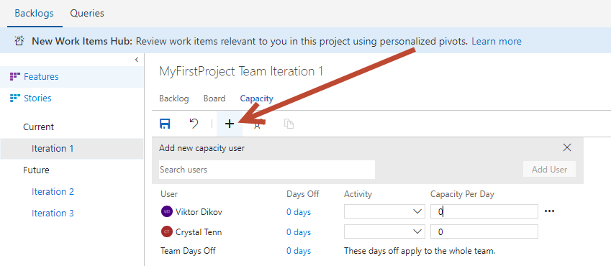

* + Setup capacity per day and roles
  + Setup time off
  + Setup 2-3 days dedicated for bug fixing.. add a task to each dev for the hours per day for 2-3 days for bug fixes at end of sprint
  + Planning Poker – Story sizing, Fibonacci (complexity), days, etc.
    - Developers, QA, & Project managers sit in room with 1-2 selected BAs. BAs are there to help answer questions about business requirements or how the User Story was written.
    - Developers and QA get to vote and discuss how long it will take
    - <https://marketplace.visualstudio.com/items?itemName=ms-devlabs.estimate> **Click Work tab > Estimate
    - The number of points taken on will set the initial “velocity”. Typically, you will use this to measure how much you take on in the future. And you can work up to taking on a few more points over time.
  + Immediately after the sprint planning meeting, developers will task out their work. Developers often will still need the BAs around to clarify further information or the technical architect on design.
  + QA will split up user stories and create tasks on the user stories they chose
  + When either all of the dev or QA time has been utilized, no more tasks will be assigned. Extra stories that have no tasks or are incomplete with tasks will be removed from the sprint. If the whole team is under capacity, another story will be pulled into the sprint.
* Sprint Duration (2-3 weeks)
  + **Standup Meeting**: 15 minutes
    - Everyone goes around the room talks about what they did yesterday, what they are going to do today, and any impediments
    - Go through 3 days of this, repeat standup
  + Setup Sprint in VSTS for both teams.
  + Developers change Code in VSTS
  + Developers do pull requests to team
  + Developers review their peers pull requests
  + Developers work with BAs to ask questions
  + Developers work with QA on bugs
  + QAs test
  + Developers push to Dev site
  + Developers push to QA with a stable Dev build so testing can occur. Can be on a schedule or based on QA approval for the release
  + BAs create additional work items for future sprints and for the backlog
  + **Sprint Grooming Session**s (2 hours, 1-2x a sprint, typically near the end of the sprint)
    - BAs,
    - Cleaning up the backlog, remove unnecessary items
    - Try to estimate Fibonacci wise sizing for high priority items
    - Asking questions about unclear items
* 2-3 days before sprint end
  + All user stories should be complete 2-3 days before
  + Only bug fixes should occur at this point
  + Multiple stable pushes to QA to get latest bug fixes to QA fast (~2 per day, noon and nightly build). Or even more frequent.
  + Final build on final day is last build. Regression test on that build.
  + PO should finalize their highest priority items in backlog
* Sprint End
  + Once regression test passes for final build, QA checks it off as good. Push that build to Prod.
* Sprint Review:
  + Team talks about how the product is going
* Sprint Retrospective:
  + Team talks how their process is going
  + Columns to talk about: What we liked/did a great of, what we need to improve, what we did terrible at/what didn’t work..
* Create a Plan to view both team’s work overall
* Process starts again the next day with Sprint Planning for next spring